**DEPARTMENT OF NETWORKING AND COMMUNICATIONS**

**FACULTY OF ENGINEERING & TECHNOLOGY**

**MINI PROJECT**

**SUBJECT CODE: 18CSC202J**

**SUBJECT TITLE: OBJECT ORIENTED DESIGN AND PROGRAMMING**

**ELEVATOR CONTROL SYSTEM**

**BY**

**TEAM MEMBERS**

**SHAURYA SINGH SRINET (RA2111032010006)**

**SHOUNAK CHANDRA (RA2111032010026)**



**SRM University, SRM Nagar, Kattankulathur-603203**

**Chengalpattu District, Tamil Nadu**

**Rubrics**

ii iiiiiIiI

|  |  |  |  |  |  |
| --- | --- | --- | --- | --- | --- |
| **Experiment Component** | **Max. Marks** | **Grading Rubrics** | | | |
| **Documentation/**  **Procedure** | 10 | UML Diagrams are well documented. The documentation supporting all functional requirement and non-functional requirement (10 Marks) | | Missing two or more required functional requirement. The documentation work not up to the mark. (5 Mark) | |
| **Concept** | 5 | Completeness of concept, consistent variable naming and relationship in static view. (5 Marks) | Completeness of concept, inconsistent variable naming and relationship in static view. (3 Marks) | | Incomplete static view. (1 Mark) |
| **Usage of Symbols** | 3 | Precise usage of symbols in dynamic view.  (3 Marks) | Improper usage of Symbol’s.  (2 Marks) | | Symbol’s misplaced in diagram. (1 Mark) |
| **Diagrams** | 4 | Completion of all 8 UML Diagrams using Visual Paradigm Tool. (4 Marks) | Construction of UML Diagrams using other tools. (2 Marks) | | Construction of few diagrams. (1 Mark) |
| **Viva and Innovative Idea** | 3 | Oral Viva and Innovative approach. (3 Marks) | Oral Viva and partial idea. (2 Marks) | | Oral Viva not fulfilled. (1 Mark) |
| **TOTAL** | 25 |  | | | |

**BONAFIDE**

iii

This is to certify that **18CSC202J - OBJECT ORIENTED DESIGN AND PROGRAMMING LABORATORY project report** titled “**ELEVATOR CONTROL SYSTEM”** is the bonafide work of **SHAURYA SINGH SRINET (RA2111032010006), SHOUNAK CHANDRA (RA2111032010026)** who undertook the task of completing the project within the allotted time.

**Signature of the Guide Signature of the II Year Academic Advisor**

Dr. Gouthaman. P

**Assistant Professor**

Department of NWC

SRM Institute of Science and Technology

**Professor and Head**

Department of NWC

SRM Institute of Science and Technology

**About the course: -**

iv

18CSC202J/ 8AIC203J - Object Oriented Design and Programming are 4 credit courses with **L T P C as 3-0-2-4** (Tutorial modified as Practical from 2018 Curriculum onwards)

**Objectives:**

The student should be made to:

* Learn the basics of OOP concepts in C++
* Learn the basics of OOP analysis and design skills.
* Be exposed to the UML design diagrams.
* Be familiar with the various testing techniques

**Course Learning Rationale (CLR): The purpose of learning this course is to:**

1. Utilize class and build domain model for real-time programs
2. Utilize method overloading and operator overloading for real-time application development programs
3. Utilize inline, friend and virtual functions and create application development programs 4. Utilize exceptional handling and collections for real-time object-oriented programming

applications

5.Construct UML component diagram and deployment diagram for design of applications 6. Create programs using object-oriented approach and design methodologies for real-time

application development

**Course Learning Outcomes (CLO): At the end of this course, learners will be able to:**

1. Identify the class and build domain model
2. Construct programs using method overloading and operator overloading
3. Create programs using inline, friend and virtual functions, construct programs using standard templates
4. Construct programs using exceptional handling and collections 5. Create UML component diagram and deployment diagram

6.Create programs using object-oriented approach and design methodologies

**LIST OF EXPERIMENTS FOR UML DESIGN AND MODELLING:**

v

**To develop a mini-project by following the exercises listed below.**

1. To develop a problem statement.
2. Identify Use Cases and develop the Use Case model.
3. Identify the conceptual classes and develop a domain model with UML Class diagram.
4. Using the identified scenarios, find the interaction between objects and represent them using UML Sequence diagrams.
5. Draw relevant state charts and activity diagrams.
6. Identify the User Interface, Domain objects, and technical services. Draw the partial layered, logical architecture diagram with UML package diagram notation.

**Suggested Software Tools for UML:**

StarUML, Rational Suite, Argo UML (or) equivalent, Eclipse IDE and Junit

# TABLE OF CONTENTS

vi

|  |  |  |
| --- | --- | --- |
| **Chapter No.** | **Title** | **Page No.** |
|  | Rubrics | ii |
|  | About the Course | iv |
|  | List of Experiments | v |
|  | Abstract | 1 |
|  | Module Description | 2 |
| 1 | Use Case & Class Case Diagram | 3 |
| 2 | Sequence & Communication Diagram | 6 |
| 3 | State Chart & Activity Diagram | 8 |
| 4 | Package, Component & Deployment Diagram | 10 |
|  | Conclusion | 13 |
|  | References | 14 |

# ABSTRACT

1

In the design procedure of the elevator control circuit, the controller- Datapath approach was used. In this approach, all the functional and memory are concentrated in the Datapath while the control signals are generated by a simpler sequence diagram. To specify the control sequence and data processing tasks of the designed digital system, a hardware algorithm has been adopted and the corresponding State chart has been used. The components have been designed with Component Diagrams and Medium Scale Integration (MMI) logic components. In this report we have implemented the elevator control system for industrial buildings like office IT spaces or a very secured government building. With the help of UML diagrams like Component diagram we have demonstrated how can we make the building more secured. Often elevators are the point of contact for many access points. Diagrams like Activity Diagrams demonstrate the basic working of the elevator. The case diagram demonstrates the total functioning of the elevator. The total system can be practically implemented in real life.

# MODULE DESCRIPTION

2

**Elevator Control System** is the system responsible for coordinating all aspects of elevator service such as travel, speed, and accelerating, decelerating, door opening speed and delay, leveling and hall lantern signals. It accepts inputs (e.g., button signals) and produces outputs (elevator cars moving, doors opening, etc.). The main aims of the elevator control system are:

* 1. To bring the lift car to the correct floor.
  2. To minimize travel time.
  3. To maximize passenger comfort by providing a smooth ride.
  4. To accelerate, decelerate and travel within safe speed limits.

# CHAPTER 1

3

# USE CASE DIAGRAM

# A use case diagram is a graphical depiction of a user's possible interactions with a system. A use case diagram shows various use cases and different types of users the system has and will often be accompanied by other types of diagrams as well. The use cases are represented by either circles or ellipses. The actors are often shown as stick figures.

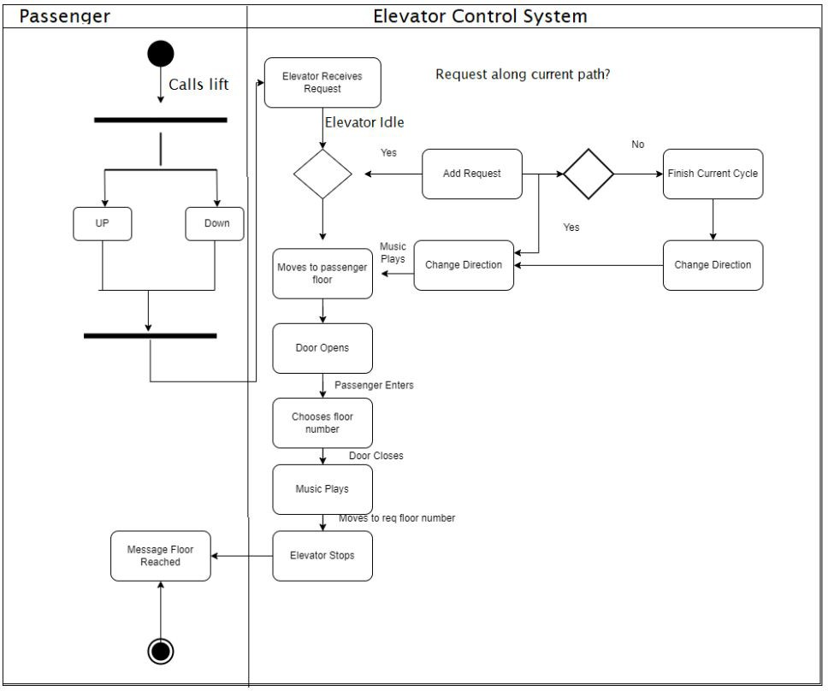

The state machine diagram depicts the following states of an elevator: Idle, Moving Down, Moving Up, Stopping, Door Opening, Door Closing, Next Stop Processing, Open Door. The diagram contains transitions between particular states, that may fire only when their condition is met:

4

* Idle to Decision - floor chosen
* Decision to Moving Down - elevator is above the current floor
* Decision to Moving Up - elevator is below the current floor
* Moving Down to Stopping - elevator approached the destination floor
* Moving Up to Stopping - elevator approached the destination floor
* Stopping to Door Opening - elevator stopped on the destination floor
* Door Opening to Open Door - door fully open
* Door Open to Door Closing - open door timer elapsed
* Door Closing to Door Opening - someone stepped into the door
* Door Closing to Next Stop Processing - door closed
* Next Stop Processing to Moving Down - elevator is above the destination floor
* Next Stop Processing to Moving Up - elevator is below the destination floor
* Next Stop Processing to Idle - no other destination available

# CLASS DIAGRAM

5

Class diagram is a static diagram. It represents the static view of an application. Class diagram is not only used for visualizing, describing, and documenting different aspects of a system but also for constructing executable code of the software application.

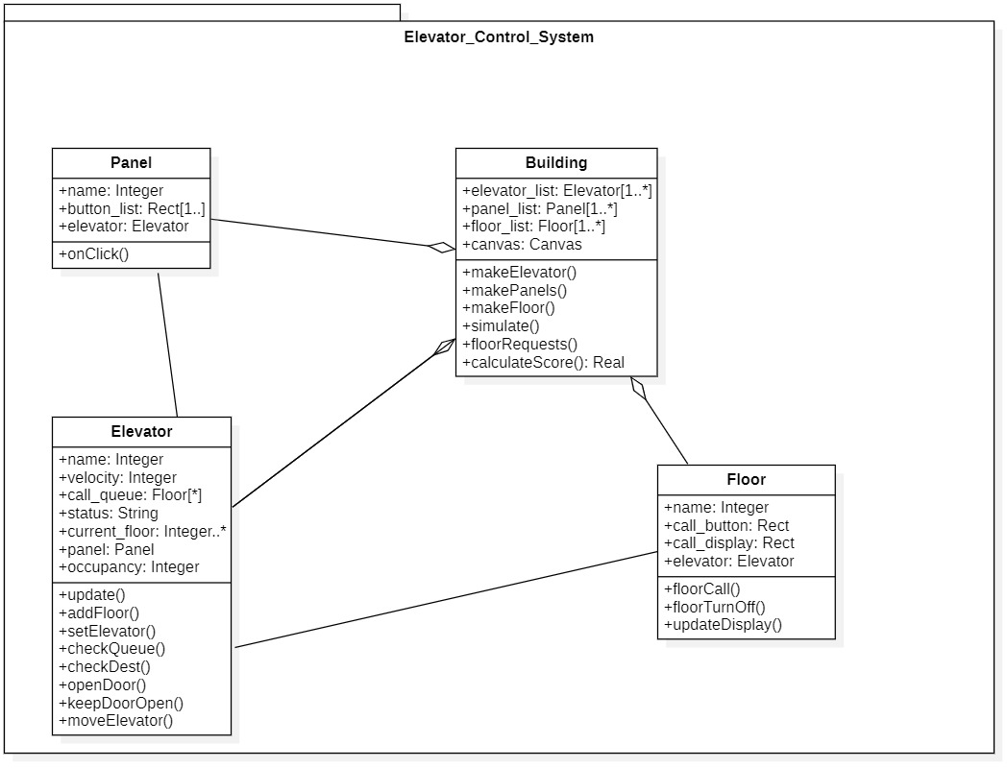

Class diagram captures the basic the basic functional aspects of the elevator button, floor button, sensor, door, floor light. The panel class is the most interacted part of the elevator. It is the panel through which the inputs for the floor are given. The building receives the request from the elevator and invokes such as make elevator(), makePanels(), makefloors(),simulate().

# CHAPTER 2

6

# SEQUENCE DIAGRAM

# Diagram Description automatically generatedUML Sequence Diagrams are interaction diagrams that detail how operations are carried out. They capture the interaction between objects in the context of a collaboration. Sequence Diagrams are time focus and they show the order of the interaction visually by using the vertical axis of the diagram to represent time what messages are sent and when.

# A sequence diagram and collaboration diagram convey similar information but expressed in different ways. A Sequence diagram shows the explicit sequence of messages suitable for modeling a real-time system, whereas a collaboration diagram shows the relationships between objects. Over here the relationship between Passenger, Elevator Button, Elevator Controller, Elevator, and the Door. Like when the passenger is passed Elevator button is invoked. Upon which the elevator control is invoked. The control thereby reinvokes instructions for the elevator and thereby asks the elevator to move. When the elevator reaches its destination door is invoked and the passenger steps out

.

.

# COMMUNICATION DIAGRAM

7

UML communication diagrams, like the sequence diagrams - a kind of interaction diagram, shows how objects interact. A communication diagram is an extension of object diagram that shows the objects along with the messages that travel from one to another. In addition to the associations among objects, communication diagram shows the messages the objects send each other.

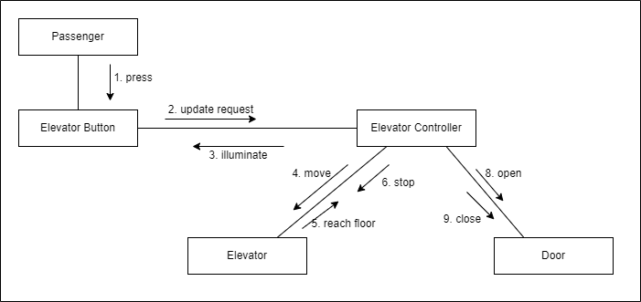

It mainly focusses on communicating between various components of a system. The same way by which a passenger communicates to the elevator button. The Button communicates the request to the elevator controller. The controller thereby moves the elevator or opens or closes the door.

# CHAPTER 3

8

# STATE CHART DIAGRAM

A State chart diagram describes a state machine. State machine can be defined as a machine which defines different states of an object and these states are controlled by external or internal events. Activity diagram explained in the next chapter, is a special kind of a state chart diagram.

# 

The state chart diagram is responsible for describing the various state of the elevator. It has a module Elevator Idle which can send 2 requests one to move the elevator up & the other to move to move the elevator down. Once the elevator starts another module called moving to floor is invoked which helps the elevator thereby to move to its destination.

# ACTIVITY DIAGRAM

9

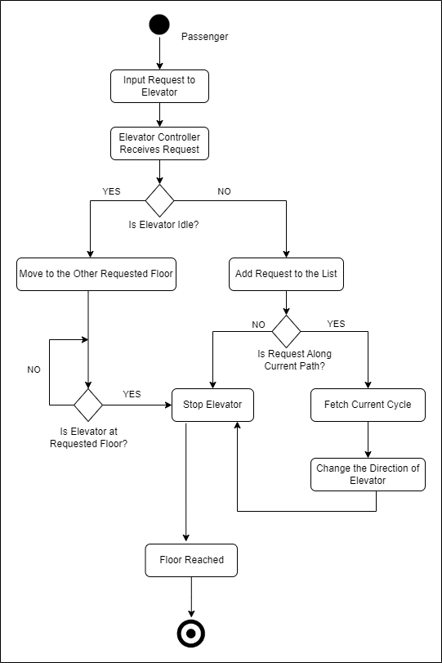Activity diagram is another important behavioral diagram in UML diagram to describe dynamic aspects of the system. Activity diagram is essentially an advanced version of flow chart that modeling the flow from one activity to another activity.

The activity diagram is regarding the various activities of the elevator. responds in Boolean. Whenever the elevator receives a request like a request from the controller it responds to it. The first request it processes is that whether the elevator is idle or not. It thereby requests its current path.

# CHAPTER 4

10

# PACKAGE DIAGRAM

# Package diagram, a kind of structural diagram, shows the arrangement and organization of model elements in middle to large scale project. Package diagram can show both structure and dependencies between sub-systems or modules, showing different views of a system, for example, as multi-layered (aka multi-tiered) application - multi-layered application model.

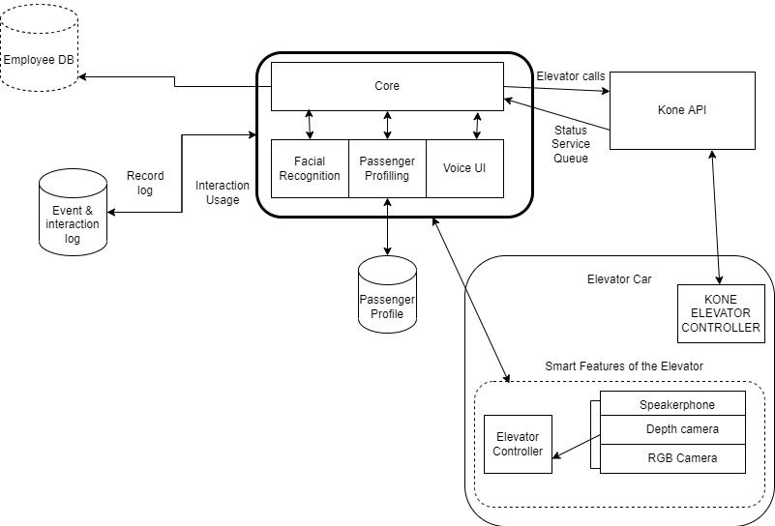

The package diagram is responsible for bringing the various packages of a diagram together. It starts with an Employee Data base which has the biometrics record of all the employees who would be using the elevator. It is kept at the core. Whenever an employee gets inside the elevator, he is first authenticated to make sure whether he really fits in the elevator. He puts his biometrics which is authenticated using KONE API and the database. There is a surveillance camera inside the elevator which records every moment inside the elevator.

# COMPONENT DIAGRAM

11

# UML Component diagrams are used in modeling the physical aspects of object-oriented systems that are used for visualizing, specifying, and documenting component-based systems and also for constructing executable systems through forward and reverse engineering. Component diagrams are essentially class diagrams that focus on a system's components that often used to model the static implementation view of a system.

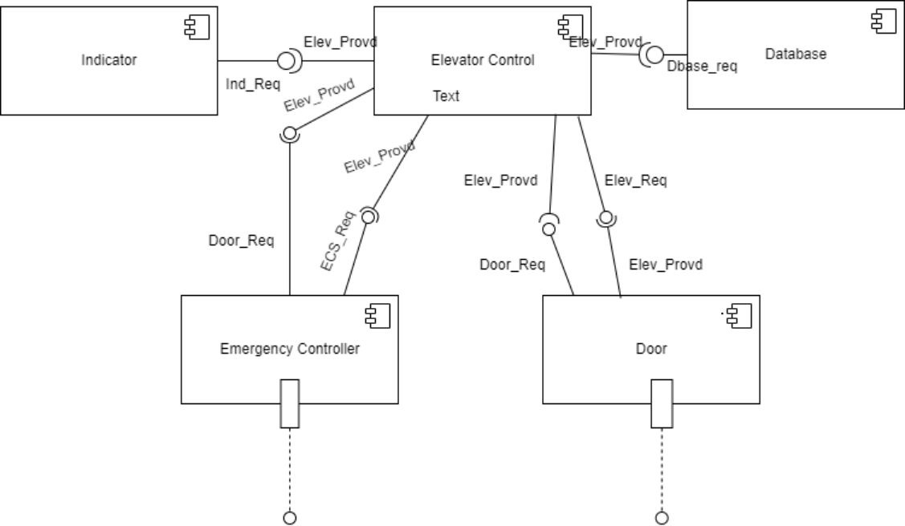

Component diagrams are essentially class diagrams that focus on a system's components that often used to model the static implementation view of a system. Over here the various components are the indicator, Elevator Control, Database and Emergency Controller and door. As the elevator moves the indicator moves the elevator controls are also invoked. The various components like the Emergency Controller and the door are called upon. The emergency control is invoked to call upon an emergency stop when there is an emergency. The door is called upon when it arrives at its destination floor.

# DEPLOYMENT DIAGRAM

12

Deployment diagrams are important for visualizing, specifying, and documenting embedded, client/server, and distributed systems and also for managing executable systems through forward and reverse engineering. A deployment diagram is just a special kind of class diagram, which focuses on a system's nodes.

18

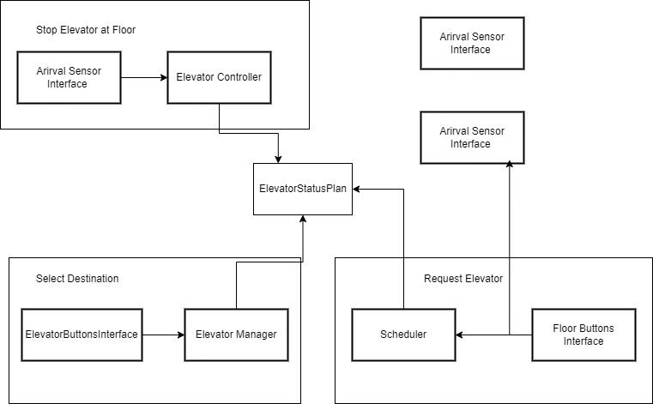

Deployment diagrams are used to visualize the hardware processors/ nodes/ devices of a system, the links of communication between them and the placement of software files on that hardware. Whenever the elevator stops at a floor the arrival sensor interface and the elevator controller are invoked due to which elevator status plan is also invoked. When a request is passed the scheduler and the floor buttons interfaces are called upon.

# CONCLUSION

13

The report on Elevator Control System has been made. The various stages of the project have been shown using various diagrams like Use Case, Class Case, Sequence, Communication Diagram, State Chart, Activity Diagram, Package Diagram, Component Diagram, Deployment Diagram. The project corresponds to a real-life elevator system for a building having multiple floors with high security at its core.

# REFERENCES

14

* [https://www.visual-paradigm.com/guide/uml-unified-modeling-](https://www.visual-paradigm.com/guide/uml-unified-modeling-language/what-is-component-diagram/)  
  [language/what-is-component-diagram/](https://www.visual-paradigm.com/guide/uml-unified-modeling-language/what-is-component-diagram/)
* <https://www.guru99.com/state-machine-transition-diagram.html>
* <https://www.web-feats.com/classes/dj/lessons/uml/elevator.htm>l
* https://www.electrical-knowhow.com/2012/04/elevator-control[system.html#:~:text=Elevator%20Control%20System%  
  20is%20the,leveling%20and%20hall%20lantern%20signals](http://www.electrical-knowhow.com/2012/04/elevator-control-system.html#%3A%7E%3Atext%3DElevator%20Control%20System%20is%20the%2Cleveling%20and%20hall%20lantern%20signals).